**Design**

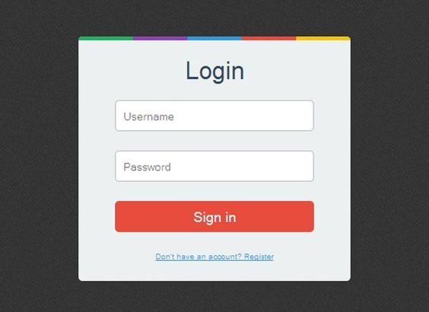

Code

import React from "react";

import {StyleSheet ,   View ,  Text } from "react-native";

export default function App(){

  return(

    <View style = {styles.container} >

    <View style={styles.box1}>

   <View >

    <Text style = {{fontSize:25  , color:"black" , fontweight : "bold"}}>login</Text>

   </View>

    <View style={styles.inputstyle}>

      <Text style = {styles.label}> User name</Text>

    </View>

    <View style={styles.inputstyle2}>

      <Text style = {styles.label }> Password</Text>

    </View>

    <View style={styles.inputstyle3}>

      <Text style = {styles.label} > Sign in</Text>

    </View>

   <View style = {styles.style1}>

    <Text style = {{ fontSize:15  , color:"blue" , fontweight : "bold"}}>

      Don't have an account? Register

    </Text>

   </View>

   </View>

    </View>

  );

}

const styles = StyleSheet.create({

  container:{

    backgroundColor : "off white",

    flex : 1,

    flexDirection:"column",

    justifyContent :"center",

    alignItems : "center",

    textAlign:"Center",

    textDecorationColor:"blue",

  },

  box1 : {

    backgroundColor:"#F9F6EE",

    width : 450,

    height : 350,

  },

  label:{

    fontSize:18,

    color:"#7d7d7d",

    marginTop:10,

    marginBottom:5,

    lineHeight:25,

  },

  inputstyle:{

    backgroundColor:"white",

    marginTop:30,

    borderWidth:1,

    borderColor : "black",

    paddingHorizontal: 30,

    paddingVertical:1,

    borderRadius:2,

  },

  inputstyle2:{

    backgroundColor:"white",

    marginTop:20,

    borderWidth:1,

    borderColor : "black",

    paddingHorizontal:30,

    paddingVertical:1,

    borderRadius:1,

  },

  inputstyle3:{

    backgroundColor:"#E3242B",

    marginTop:30,

    borderWidth:1,

    borderColor : "black",

    paddingHorizontal:100,

    paddingVertical:1,

    borderRadius:1,

  },

  style1:{

textDecorationLine : "underline",

textDecorationColor:"blue",

marginTop:50

  }

})

Result

